Curriculum Vitae

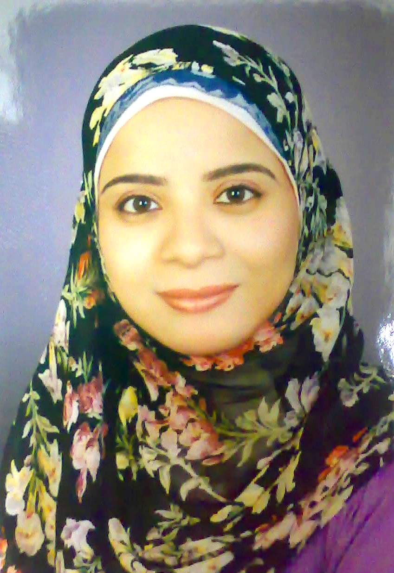 |  | Telephones:  Home: 0020889201051  0020882348616  Mobile:002 01063404087  E-mail: nahedahmed10@Gmail.com |  |  |  |  | Nahed Ahmed Abel- Monaim Elossily  Lecturer assistant  Medical Parasitology Department, Faculty of Medicine, Assiut University, Assiut  EGYPT, 71516  Date of Birth: 16 Nov, 1980  Martial Status: Married  Gender: Female
 |  |  |  |  |  |  | Certificates
Bachelor of Medicine and Surgery at 2004 from Faculty of Medicine, Assiut Univ. Egypt.
Master Degree (Medical Parsitology) at September 2008. The Thesis title "Immunological diagnosis of Schistosomiasis"
Egyptian Supervisors (References)
Prof. Dr. Refaat Ahmed Khalifa, Prof of Medical Parasitology, Medical Parasitology Dept., Faculty of Medicine, Assiut Univ., Egypt.
Prof. Dr. Mohamed El salahi Monib, Prof of Medical Parasitology, Medical Parasitolgy Dept., Faculty of Medicine, Assiut Univ., Egypt.
 |  |  |  |  |  |  | Courses attended
I had a B. Sc. Certificate with a general grade of Distinction with Honor with the percentage of 89% and I attended the following courses
3. Methodology |  |  |  |  | 2. Statistics |  | 1. Public Health and Community Medicine
6. Medical Entomology |  |  |  |  | 5. Medical Protozology |  | 4. Medical Helminthology
7. Immunoparasitology
Computer Skills
 | 3. MS Excel |  |  | 2. MS Word |  |  |  | 1. IT
 | 6. MS Access |  | 5. FrontPage (HTML) |  |  |  |  | 4. MS PowerPoint
 | 8. E-Learning with Learning Management System (LMS) |  |  |  |  |  |  | 7. Using computer and managing files
 |  |  |  |  | Workshops
Alexandria Univ., 2009 |  |  |  |  | Basic techniques in cell culture
Assiut Univ., 2010 |  |  |  |  | Protein analysis and applications
Theodor Bilharz Research Institute 2012 |  |  |  |  | Experimental Schistosomiasis and Fascioliasis
Assiut Univ., 2007 |  |  |  |  | University teacher preparing
* Attendance of 10 training programs under subordination of Faculty and Leadership Development Project

2. Effective communication skills |  |  |  |  |  | 1. E- Learning
4. Teaching large numbers and small numbers |  |  |  |  |  | 3. Thinking Skills
6. Recent trends in teaching |  |  |  |  |  | 5. Legal aspects of university
8. Strategic Planning |  |  |  |  |  | 7. Scientific Publications
10. Use of technology in teaching |  |  |  |  |  | 9. University administration
 |  |  |  |  |  |  | Teaching Experience
Seven years experience in teaching courses for the following academic colleges of Medicine, Pharmacy and Veterinary Medicine:
3. Medical and Vet. Entomology |  |  |  |  | 2. Medical and Veterinary protozology |  | 1. Medical and Veterinary Helminthology
4. Immunoparasitology
 |  |  |  |  | Laboratory experiences
1. Proficiency in the use of laboratory tools and equipment such as (Centrifuge) and Microscopical Examinations of specimens such as blood, stool, urine etc. for detection of parasites.
2. Computer proficiency in dealing with programs group of MS Office for data entry and chart drawn and their analyzing by the statistical software (SPSS & SAS) and comment on those submissions.
 |  |  |  |  |  |  | Languages
1. Arabic as a native
2. English (good in understanding and spoken)
3. French (very little)
 |  |  |  |  |  |  | Talent
Reading - Compilation and simplification of science - teaching - writing scientific articles in Arabic and English
 |  |  |  |  |  |  | Functional behavior
Praise to God; good behavior, where not submitted any complaint against me and not referred for legal affairs, never during my service in Medical Parsitology Department, Assiut Univ. from the beginning of the academic year 2006 to 2013 academic year

Declaration
I hereby declare that the given information is true to the best of my knowledge and belief.

Nahed Ahmed Abde-Elomoaim Elossily

